Pre-K Camp Calendar
June/July/August
Weekly Themes | Monday | Tuesday | Wednesday | Thursday | Friday
Community  Helpers | 24 Welcome to  Summer Camp | 25 Doctor | 26 Police | 27 Post Office | 28 Fire Safety
America  The Beautiful | 1  Lobsters | 2 Costume Party&  kids Party Time | 3 STEPPING Stones: Dinosaurs | 4  NO CAMP  Happy 4th! | 5  NO CAMP  Happy 4th!
Summer  Safari | 8 Monkeying Around | 9 Lions & Tigers | 10 Music With Judy | 11 Elephants & Giraffes | 12 Zebra Stripes
Ocean Animals | 15 Pirates & Princesses | 16 Ships & Carriages | 17 Mr. Bungles | 18 Parrots & Unicorns | 19 Tiaras & Treasure
A Day at The Beach | 22 90’s Nostalgia | 23 50’s Sock Hop | 24 60’s Tie Dye Shirts | 25 70’s Disco | 26 80’s Neon
Gone  Camping | 29 Happy Campers | 30 Making S’Mores | 31 Critter Caravan  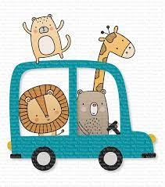 | 1 Campfire Stories | 2 Ice Cream Fun

